**Problem Statement**

The findings reveal that near universal adoption (80%) of even weak masks (20% effective) could prevent 17 - 45% of projected deaths over two months in New Work and reduces the peak daily death rate by 34-58% of COVID-19. Their results strongly recommend the use of the face masks in general public to curtail the spread of Coronavirus. Further, with the reopening of countries from COVID-19 lockdown, Government and Public health agencies are recommending face mask as essential measures to keep us safe when venturing into public. To mandate the use of facemask, it becomes essential to devise some technique that enforce individuals to apply a mask before exposure to public places. Face mask detection refers to detect whether a person is wearing a mask or not. In fact, the problem is reverse engineering of face detection where the face is detected using different machine learning algorithms for the purpose of security, authentication and surveillance.

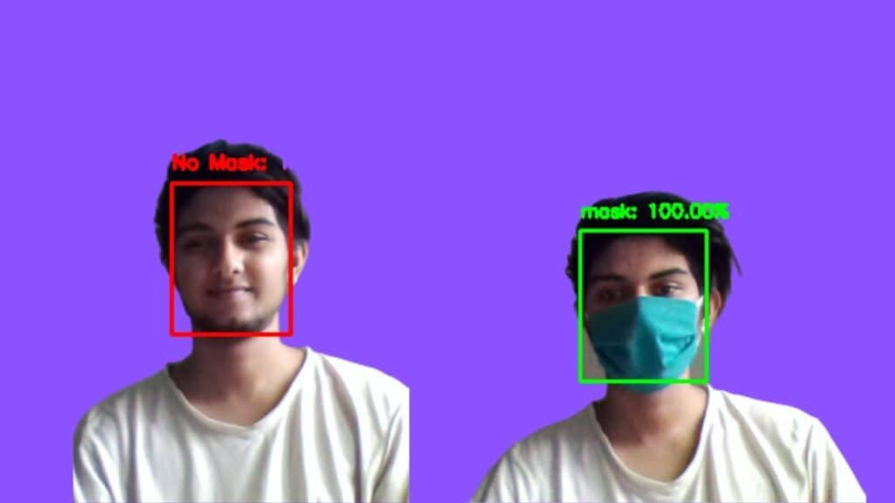

**Abstract**

The COVID-19 pandemic is causing a worldwide emergency in healthcare. This virus mainly spreads through droplets which emerge from a person infected with coronavirus and poses a risk to others. The risk of transmission is highest in public places. One of the best ways to stay safe from getting infected is wearing a face mask in open territories as indicated by the World Health Organization (WHO). In this project, we propose a method which employs OpenCV to detect face masks on people. A bounding box drawn over the face of the person describes weather the person is wearing a mask or not. If a person's face is stored in the database, it detects the name of the person who is not wearing face mask and the warning shows on display to the persons that they are not wearing a mask so that they can take precautions. The demand for an efficient system for detecting face masks on people for transportation means, densely populated areas, residential districts, large-scale manufacturers and other enterprises to ensure safety. This project uses machine learning classification using OpenCV to detect facemasks on people.

**Flowchart**

**Start**

**Stop**

**Stop**

**Stop**

**Detect all faces using face detector**

**If no faces**

**Shows the message (No Mask) on display**

**Input Images**

**If a face detected has a mask**

**Detected output is shown**

**Recognition of face is done**